**CS 6314.001/002- Practice Work 7**

**Due date:** March 31, 2020, 11:59pm

Implement a simple RESTful web service using PHP.

Your web service will provide information about books.

**http://localhost/books** will give list of books that are stored in your database.

Results will be in JSON format.

***

**Steps:**

**1.** First create the database table.

Database name: PW7

Database schema is as follows:

Books(ISBN, Author, Title, Price, Category)

CREATE TABLE Books(

ISBN char(10),

Author varchar(100),

Title varchar(100),

Price Decimal(10,2),

Category Varchar(40)

);

**2.** Populate your table by using books.sql file (available on eLearning).

Copy/paste sql statements into SQL tab on phpMyAdmin and execute all statements by clicking Go button.

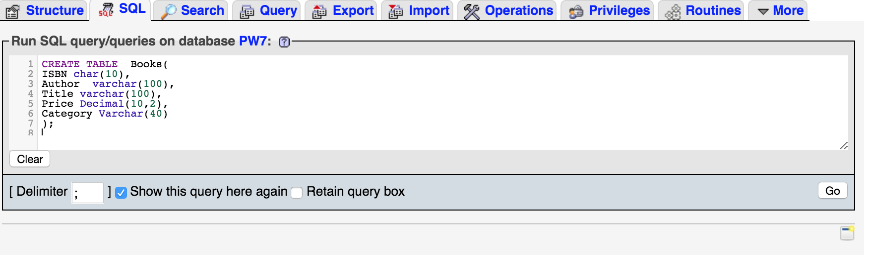

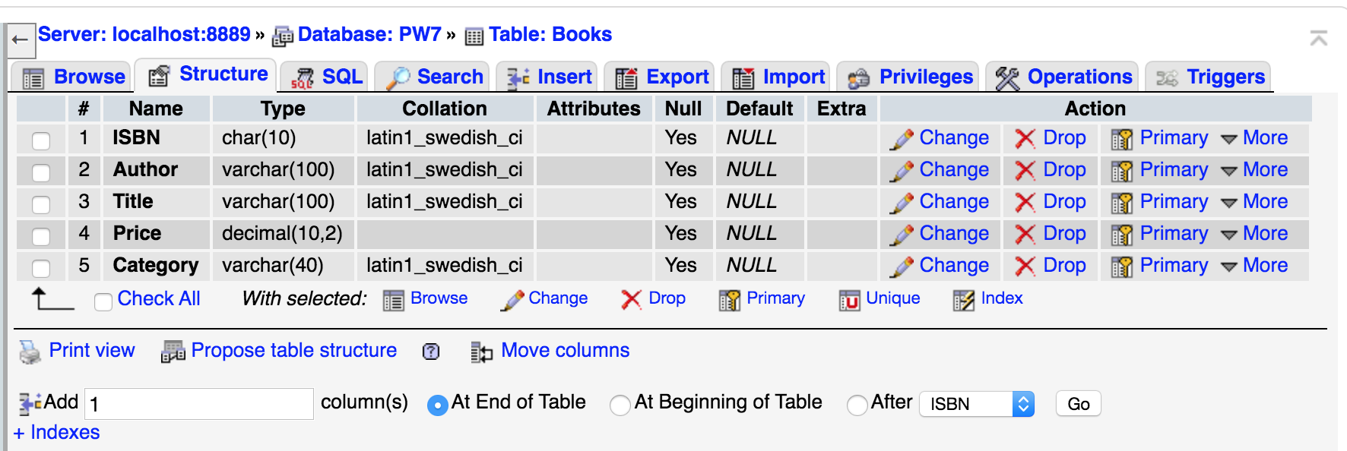

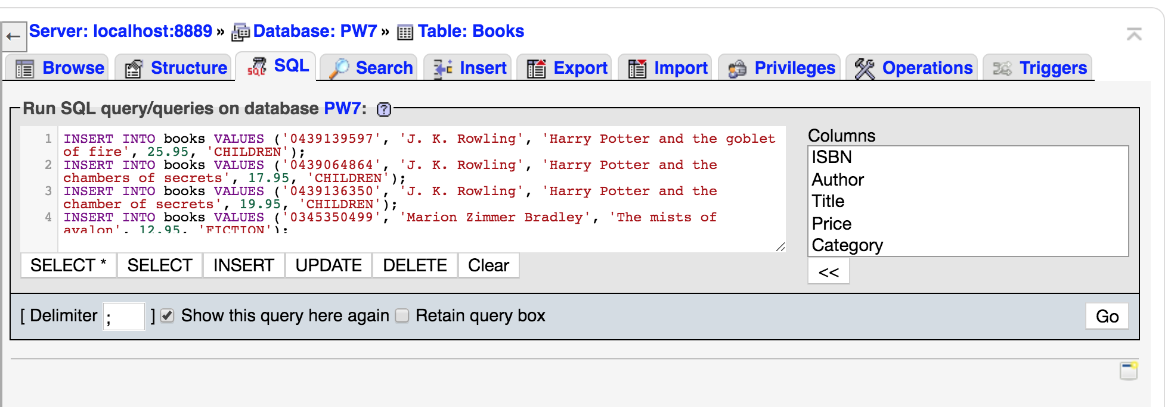

**3.** You will need to configure your MAMP server to define an API end point (URL) for your web service.

**Configuration changes for Mac OS:**

Create **api** folder under Applications/MAMP/htdocs/ directory.

Save index.php under Applications/MAMP/htdocs/api/ directory.

Open apache configuration file (Applications/MAMP/conf/apache/httpd.conf) in a text editor.

Search for <IfModule alias_module>

Anywhere within that module, add following line:

Alias /books "/Applications/MAMP/htdocs/api/index.php"

**Configuration changes for Windows:**

Create **api** folder under “C:/MAMP/htdocs” directory.

Save index.php under “C:/MAMP/htdocs/api” directory.

Open apache configuration file (C:/MAMP/conf/apache/httpd.conf) in a text editor.

Search for <IfModule alias_module>

Anywhere within that module, add following line:

Alias /books "C:/MAMP/htdocs/api/index.php"

**4.** Save httpd.conf file.

**5.** Restart apache server.

**6.** Check your api at <http://localhost/books>.

It should show the results of index.php.

Please note that your result will not be in HTML but in JSON format (structured data). It will be an array of JSON objects. See the result below.

**Solution hint:** Retrieve all records from database and use json_encode() function to encode them into JSON.

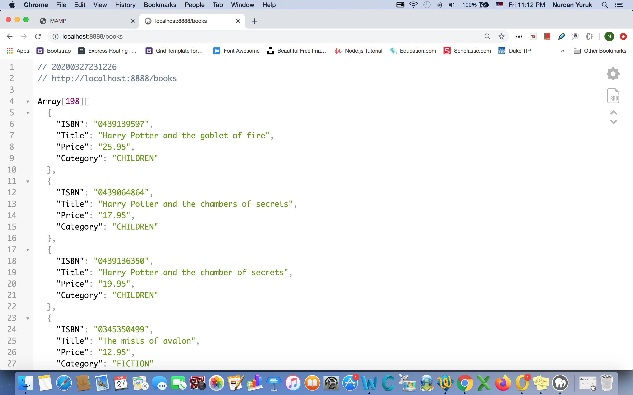

Your result might look different from the above result. For this look, I have installed JSON Viewer extension on Google Chrome. This plugin displays the selected JSON string in a tree view. You don’t need to install the plugin. As long as your result is correct (an array of JSON objects), you are fine.

**Deliverables:**

Zip index.php file and screenshot of the results into yournetid-PW7.zip and submit through eLearning.

**Important reminder:** Make sure your database name (PW7), table name and attribute names are same as given names. You also make sure to use default hostname, username and password for database connection. (host: localhost, username: root, password: root). If your database connection parameters are different from the default, change them before submitting your work. Otherwise you will lose points for not complying with the standards of the assignment.